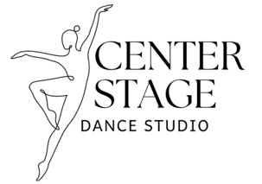
Our Website Provides
Studio Information and
Schedule
WE WILL NOT HAVE DANCE
MONDAY
JANUARY 19

January Newsletter

BARBIE ALL INCLLUSIVES
WEEK OF RECITAL

MONDAY, MAY 18TH
STUDIO A
All Inclusive ONLY
5:00-7:30 pm
NO Regular Classes
STUDIO B
REGULAR CLASSES

TUESDAY, MAY 19TH
ALL REGULAR CLASSES

WEDNESDAY, MAY 20TH
STUDIO A
All Inclusive ONLY
5:00-7:30 pm
NO Regular Classes
STUDIO B
REGULAR CLASSES

THURSDAY, MAY 21ST
STUDIO A
All Inclusive ONLY
5:00-7:30 pm
NO Regular Classes
STUDIO B
REGULAR CLASSES

FRIDAY, MAY 22ND
Rehearsal at 5:00 pm

SATURDAY, MAY 23RD
Show at 5 pm
COMPETITION CORNER
REMINDER TO ORDER STONES FOR STONING DAY, JAN 11TH!!!
AND LIPSTICKS & MAKEUP FOR
HAIR & MAKEUP DAY, JAN 15TH!!!

UPCOMING IMPORTANT DATES
January 1st – Nationals Entry Fees Due
Apparel Fees Due

January 11th – Mom’s Stoning
12:00-6:00 pm
Solo/Duo/Trio
1:00-4:30 pm

January 15th – Hair & Makeup Class
5:15 pm- 6:00 pm
NEW DANCE MOMS STAY AFTER

January 20th – Competition Mindset Day
6:00-7:00 pm

January 25th – Show Off @ HCHS
12:00 pm Arrive
3:00 pm Show Starts

January 29th – All Inclusive Rehearsal for Travel Team

January 20th-31st – Celebration Talent Comp – Travel Team – Atlanta
February 8th – Solo/Duo/Trio
1:00-4:30 pm

February 19th – All Inclusive Rehearsal for Expressions
6:00-7:00 pm

February 20th-21st – Expressions
Valdosta

THE WEEK OF JAN 26TH - 30TH!
TACKY WEEK
Wear your favorite mismatched items!

OUR 26th SPRING RECITAL IS…
May 22-23rd
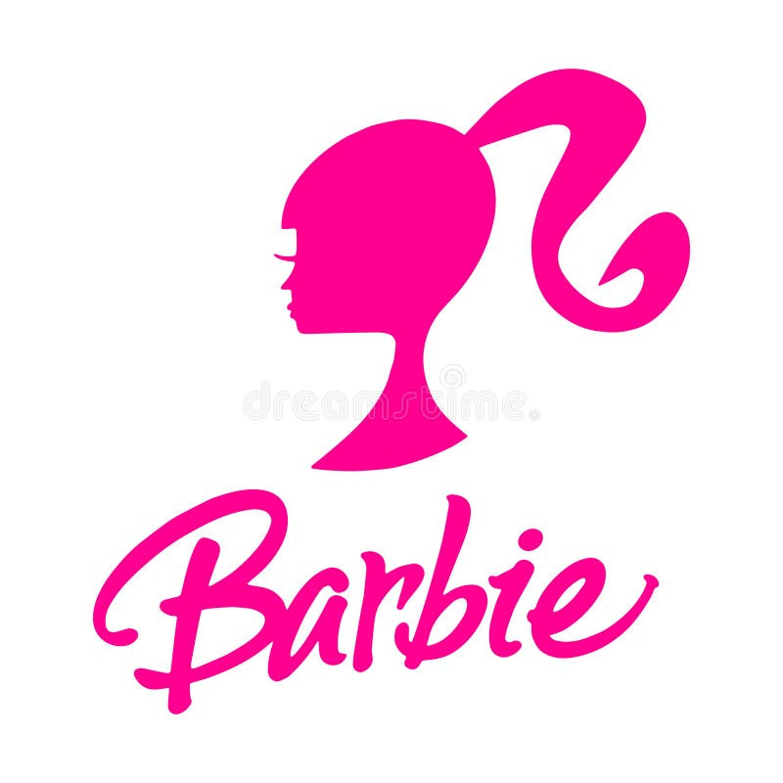

REFER A FRIEND
AND GET $15 OFF
ONE MONTH OF TUITION
