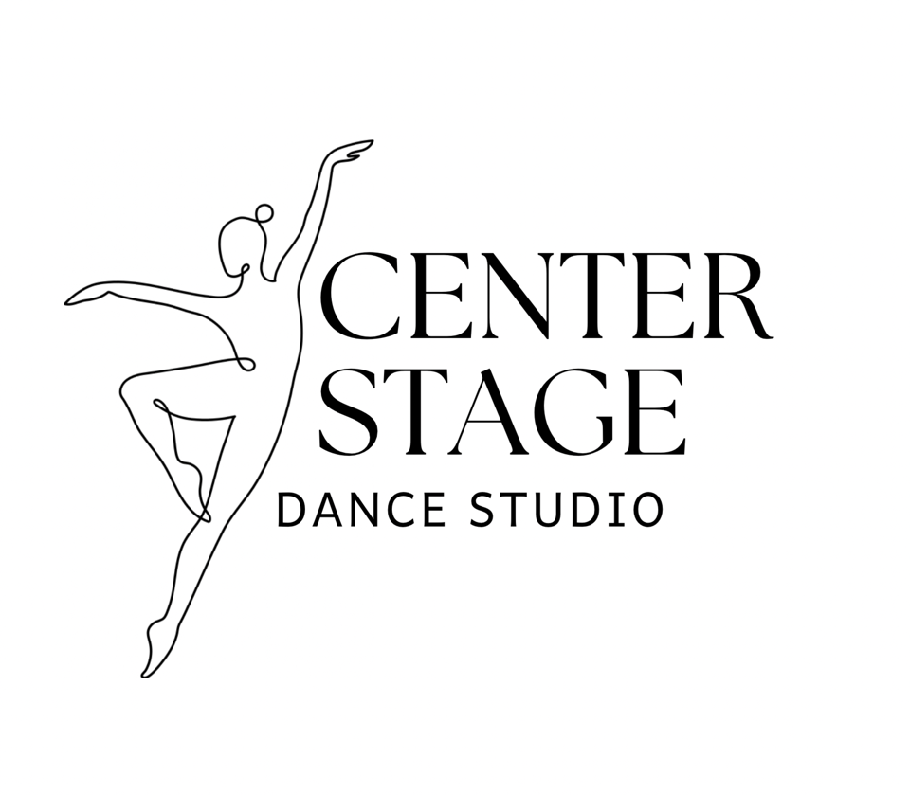
81 Hunter Road, Cataula, GA 31804
706-628-9187
(Phone hours Monday-Friday 9 a.m. – 5 p.m.)

welovecsds@gmail.com
Facebook: Center Stage Dance Studio
Instagram: welovecsds
TikTok: welovecsds

Serving Harris County for 26 years

Website- welovecsds.wixsite.com

“Motivating young minds to be the best they can be.”

Our studio policies are in place to help maintain the safety and professionalism of our studio. All students and families who enter CSDS must adhere to these policies.
REGISTRATION FEE:
- $65.00 non-refundable registration fee, which includes your child’s uniform to be worn for the entire dance year, as well as for the Christmas recital. Fee is good for the entire dance year, August 2023-May 2026. If tuition is not paid for August, we cannot guarantee a spot for your child in your chosen classes.
MONTHLY TUITION:
Monthly tuition is $40 per month per class.
1 class= $40
2 classes= $80
3 classes= $120
4 classes= $155 (classes drop to $35/class)
5 classes= $190
6 classes= $225
7 classes= $255 (classes drop to $30/class)
8 classes= $285
9 classes= $315
10 classes = $340 (classes drop to $25/class)
Unlimited classes- $350
*We give SIBLING DISCOUNTS- Ask about sibling rates!
- Tuition payments are divided up over a ten-month period. The majority of the months have 4 dance nights per month; however, tuition is not prorated for months that have 3 dance weeks as well as 5 dance weeks (we do not charge extra for months with 5 dance nights).
- Tuition is due on the first dance class of each month and is considered late on the 10th of each month. Tuition is automatically processed on the 10th of each month.
- A $25 late fee is automatically incurred on the 11th of each month for declined cards.
PAYMENTS:
- Each dancer will be required to have a credit/debit card on file.
- Payments must be submitted at the time of ordering apparel, shoes, tights either via card on your jackrabbit account or cash.
- We accept Visa/MasterCard/American Express and Discover.
- We DO NOT take checks for any reason.
- Online payments for apparel/etc can be made through your jackrabbit account that you will set up during registration.

OUTSTANDING ACCOUNTS:
- If we don’t receive payment for more than two months, your child will not be allowed to dance until the bill is paid in full.
CHANGES OR WITHDRAWAL:
- To change/discontinue classes please email us 2 weeks prior to changes in order for us to adjust our choreography.
UNIFORM:
- Students must have proper class uniform, designated leotard/tank/shorts/tights, and appropriate shoes for each class. Hair must be tied back. No jewelry. Please put your child’s name on all shoes & dance bag.
- Your registration fee will include your uniform; however, you are welcome to purchase any other items at Passe’ and Plie’ (our studio store).
CELL PHONES
- Dancers cannot use cell phones in dance studio. They must remain in the dressing area. Competition dancers must place cell phones in our holder.
FOOD/CANDY
- No candy or food allowed in dressing areas or dance studio. WATER ONLY.
CLASS CANCELLATIONS:
- Classes may be combined/cancelled classes in the event of low attendance, inclement weather, or other emergencies. You will be notified via e-mail if a class is cancelled. It will also be posted on our social media pages, and it will be sent through Jackrabbit email.
- We follow the Harris County School System calendar. If there are any exceptions, they will be announced in our monthly newsletter and posted on our social media pages.
RECITALS:
- Christmas Recital December 19-20th. students wear their designated leotard/uniform.
- Spring recital (TBA) costumes are ordered in October, in order to receive costumes in time for exchanges (if necessary).
COSTUME FEES:
- Spring recital costume fees are due on or before 10/01/2025. Your child will have one costume per class. Costume fees will be $65 per costume prior to 10/1/2025.
- All costumes paid after 10/01/2025 will be $85 and will be added to our January order. In order to ensure your child’s costume is received on time, please submit a costume payment prior to 10/1/2025.
- We will offer Christmas and Spring Recital Packages. Keep in mind the recitals are optional. Our Recital Package includes 2 adult tickets and a closing number t-shirt for your dancer.

